Project name: Programming Exercise 1
Module name: Login Module with Input Validation & Type Checking
Developer: Calvin Brewer
Course: CEN 4078 Secure Software Development
Date: 9/13/2026

Table 1. Login Module Test report
Data | Proof  - may be copy of code snippet  - may be screen captures  - may be written proof but must have data not just prose
Login Module
Create an application to allow users to login | 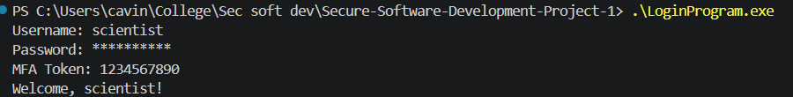
Create three users: (include the usernames) | 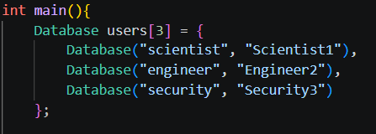
Create three passwords: (include the passwords)

Database: An array of the usernames and passwords | 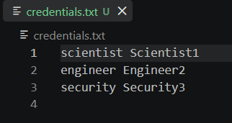
Prompt the user for a username | 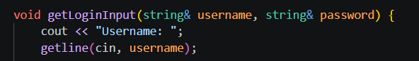
Prompt the user for a password | 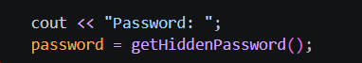
The password should not be visible | 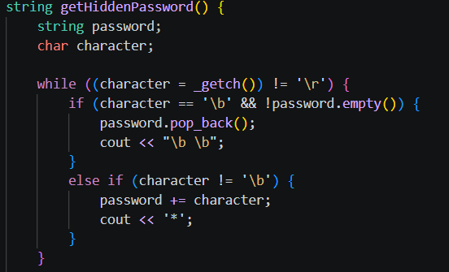
If the login is successful, display a welcome message with the username in it | 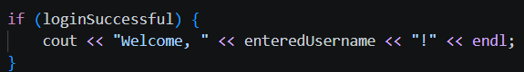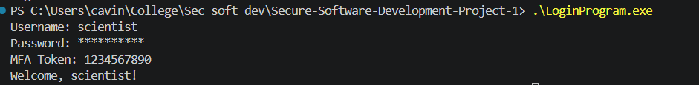
If the login is not successful, handle it in a “Secure Software Development” way. | 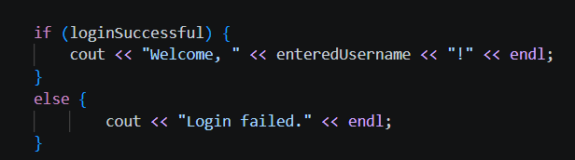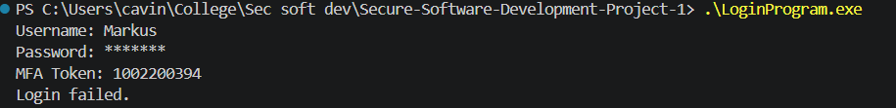
Input Validation & Type Checking
Create a validation class in your login module | 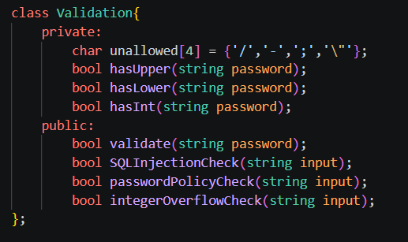
Create a SQL Injection validation method | 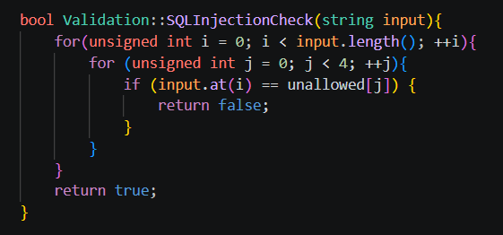
Create a Password Policy validation method | 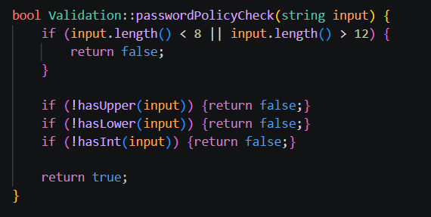
Create an Integer Overflow validation method | 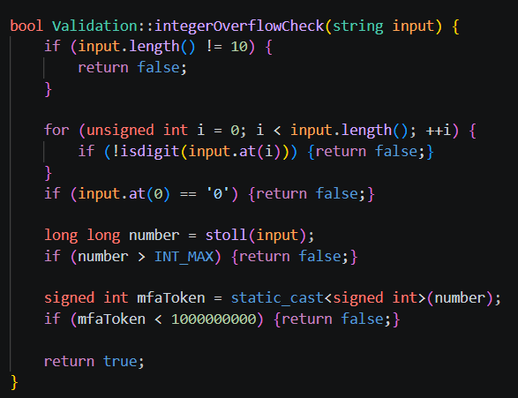
Validate the username with SQL Injection.  Show pass and fail. | 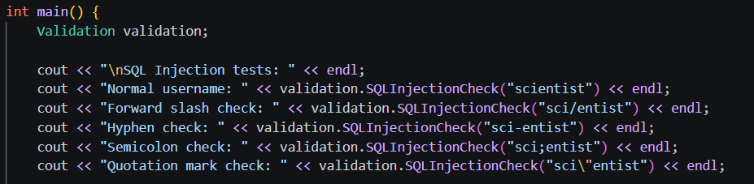  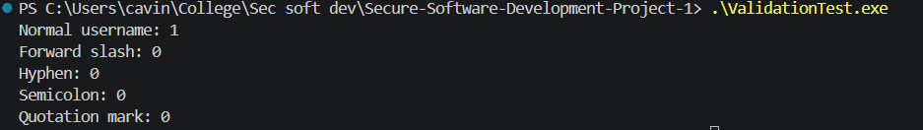
Validate the password with SQL Injection and Password Policy  Show pass and fail. | 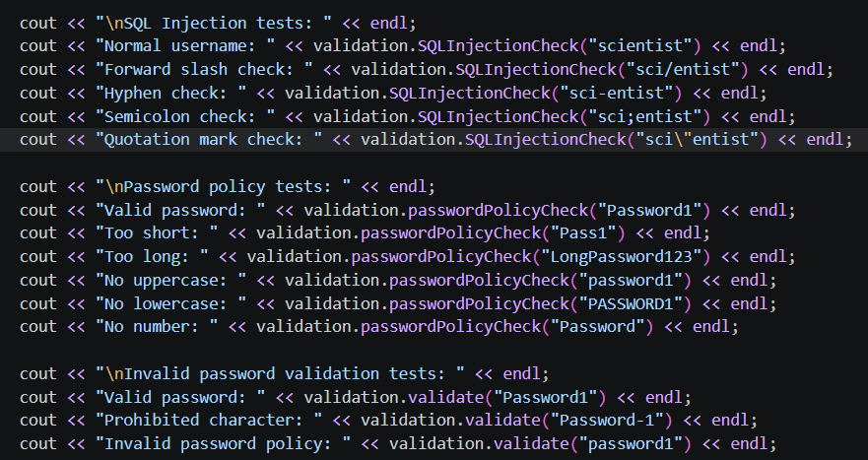  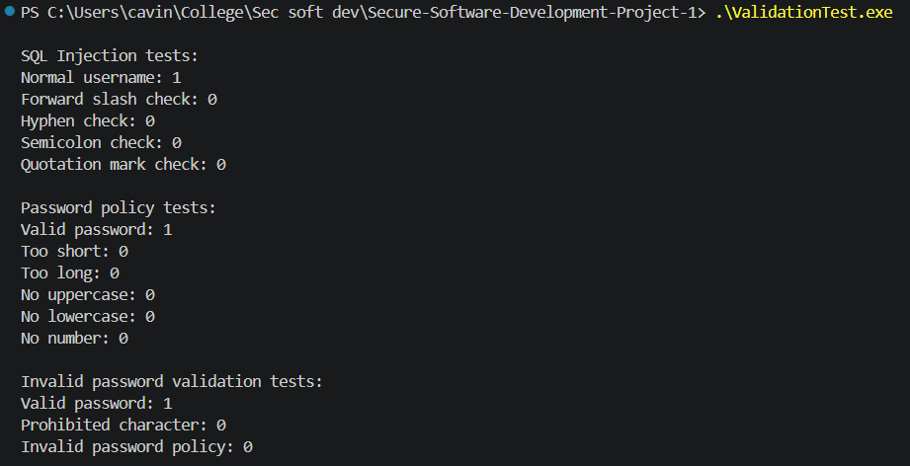
Validate the MFA with Integer Overflow  Show pass and fail. | 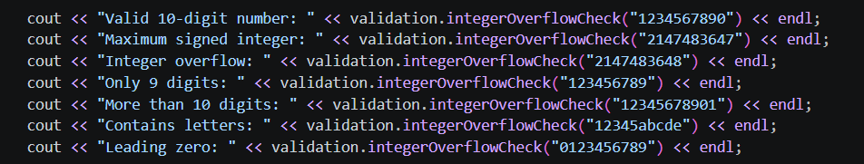  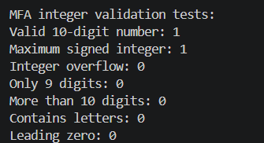
Summary
Did you meet all the requirements? If not, describe why? | Yes, all programming and testing requirements were met.

